**GAN Lab activity handout**

**[0] Open the ‘GAN_lab_activity.ipynb’ file, and run the first 8 cells (import modules and define functions)**

**[1] Define the hyper-parameters**

Run the cell

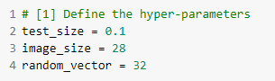

**[2] Obtain the dataset ‘0’ (100 images) and ‘1’ (1,000 images) from Mnist**

Run the cell

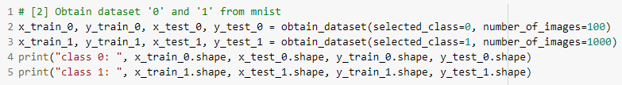

To get the following output

**[3] Create imbalanced dataset from step #2**

Run the cell

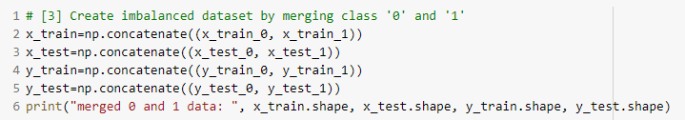

To get the following output

**[4] Build, train, and test a classifier using the imbalanced data (result: ROC, AUC)**

Complete the code and run the cell

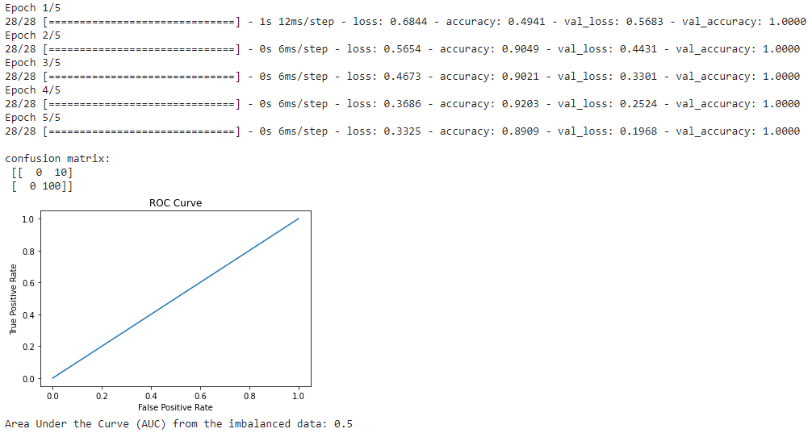To get the following output

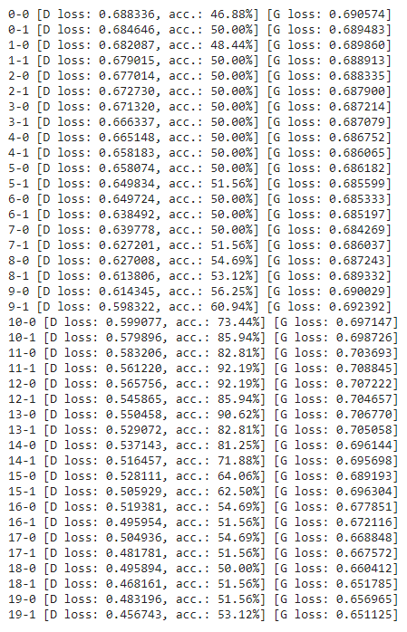

**[5] Build and train GAN**

Complete the code and run the cell



To get the following output



**[6] Create fake data using GAN for class ‘0’**

Complete the code and run the cell

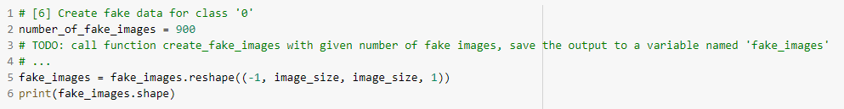

To get the following output



**[7] Merge fake data with the original data**

Complete the code and run the cell

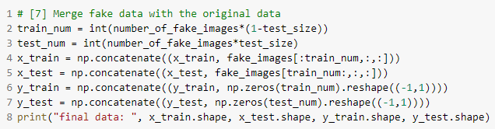

To get the following output



**[8] Build, train, and test a classifier using the balanced data (result: ROC, AUC)**

Complete the code and run the cell



How does the output look like?

Is there any difference with the output of step number 4?

Please create a report to briefly explain the results. Attach the code that you wrote and the screenshots of the outputs. Submit the report **before 03/12 (today) 23:59:59.**